Data Project: Blackwell

Electronics’ eCommerce Data

By: Doretha SmithJenkins

Date: December 13, 2022

# Mission

Customer: Blackwell’s Electronics

Group: eCommerce Team Our Mission:

● To help customer maximize revenue for eCommerce sales by:

○ Analyzing customer purchasing behavior using sales data from Blackwell’s Electronics' eCommerce sales team.

○ Analyzing customer demographics to understand improvement in marketing strategies.

# Data Snapshot

Blackwell Electronics' Sales Data:

* Customer Transaction Data – Data collection started over a year ago
* Total Data Points: 80,000
* Data Received:

○ Transaction Type – Instore or Online

○ Customer Age

○ Number of Items

○ Amount Spent per transaction

○ Region

# Data Mining Objectives

* Evaluate Customer Purchasing Behavior
  1. Amount Spent by Region

○ Amount Spent vs. Number of Items Purchased

○ Customer Age by Region

* Evaluate Customer Demographics
  1. Prediction of customer age by other demographic data

○ Customer Age by Online vs. Instore Transaction

# Data Processing Highlights

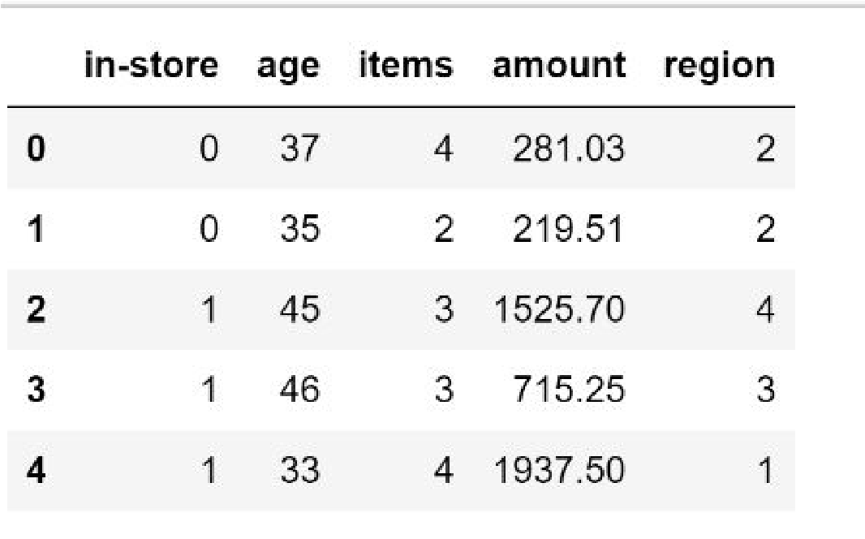**Data Age Groups:** Millennials, Gen X, Baby Boomers

**Regions:** North, South, East and West

**Transaction Type:** Instore and Online

**Amount Spend:** Up to $3000

**Number of Items Purchased:** 1 through 8

## Purchase Trends by Region

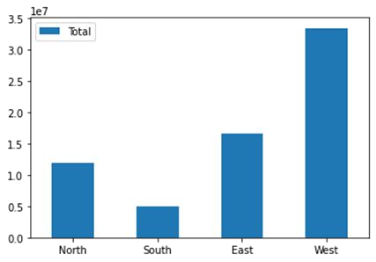

Millions($)

|  |
| --- |
| Highest: West Region, $3.3M (total) $1,283 (average) Lowest: South Region, $.5M (total) $252 (average) |

Regions

* West Region Spends Most; South Region Spends Least. Nearly double spent in West as compared to North and East
* Decreasing trend beyond $1000 per transactions
* Spending more does not necessarily mean more items purchased.

# Customer Age Group

* 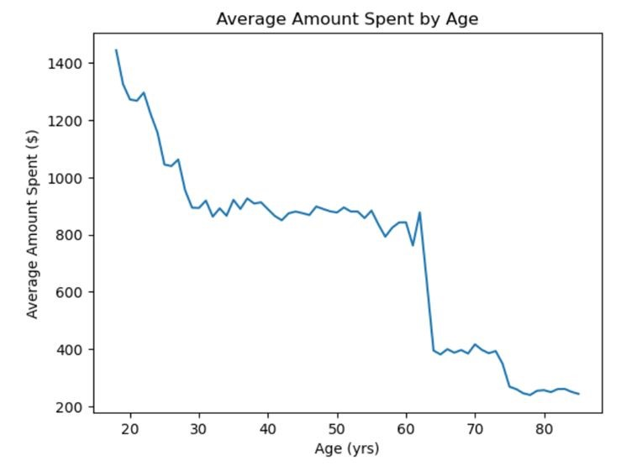18 – 85 years customer age group
* Age group 30 – 55 years active buyers
* West Region has younger group; South Region has older age group
* North and East region covers wide age group
* Age was found to not be a strong indicator of customer spending. Region is strong indicator of customer spend.

# Customer Preference for Transactions

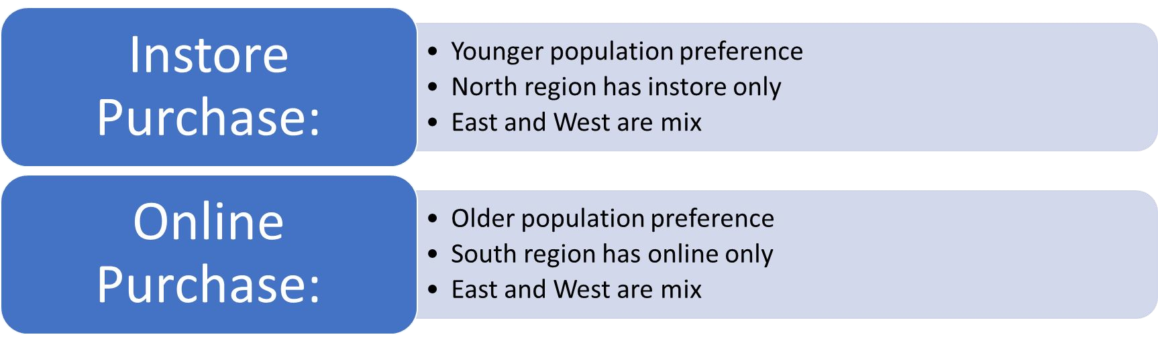

# Recommendations

Recommendations for Marketing Strategies:

* Evaluate marketing strategies in West and replicate for other regions.
* Focus marketing for younger age group. (< 30 years)
* Evaluate pricing structure for transactions that cost more than $1000.
* Market older age group for instore purchases and younger age group for online purchases.

**Questions??**